**VIETNAM NATIONAL UNIVERSITY OF HANOI**

**UNIVERSITY OF ENGINEERING AND TECHNOLOGY**



**DATABASE PROJECT REPORT**

**\*\*\*\*\*\*\*\*\*\*\***

**TOPIC: BOOK INFORMATION WEBSITE**

Student name: Bế Trọng Nghĩa

Course: INT2211 42

Teachers: Nguyễn Hải Châu – Phạm Thị Quỳnh Trang

**TABLE OF CONTENTS**

Contents Page

**Part I**: *Application* *overview ............*........................................................................................... 3

**Part II:** *Database of the application and its logic ....................................................................* 11

**Part III:** *Database’s ERD (Chen’s model) ...............................................................................* 14

**Part IV:** *Database’s Relational Model .....................................................................................* 15

**Part V:** *Database’s Implementation in MySQL ........................................................................* 17

**Part VI:** *Application development summary .............................................................................* ??

Note: There are some inconsistencies:

* The ER diagram’s entities are singular nouns, but the SQL implementation used plurals.
* Category is changed into Genres in the SQL implementation.

**Part I**

**Application overview**

**\*\*\*\*\*\*\*\*\*\*\***

The website was built with the idea of a database of books related information. This includes books and their authors, publishers, and genres.

1. 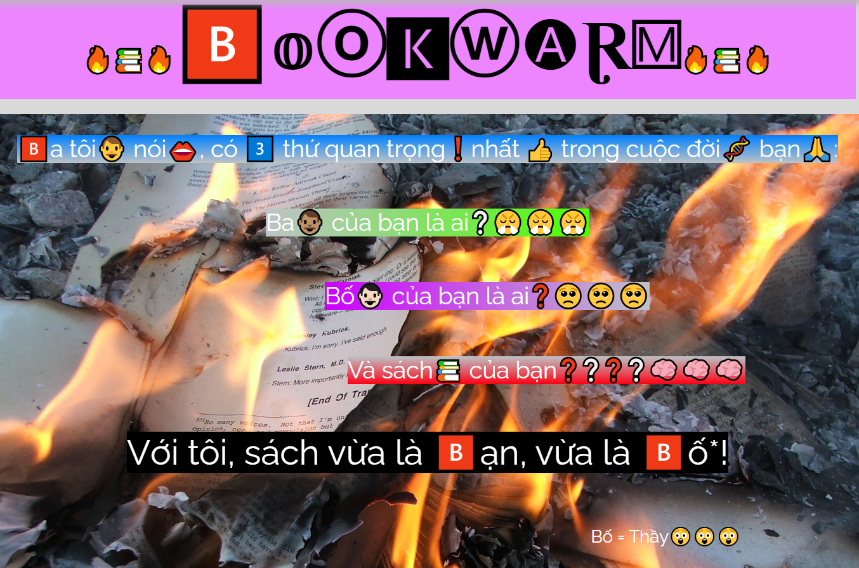The Homepage

*The design is very human.*

The Homepage is a brief preview of the website’s functionalities, with unfunny quotes, esoteric design, and relaxing lofi music, promising a unique experience to the site’s visitors.

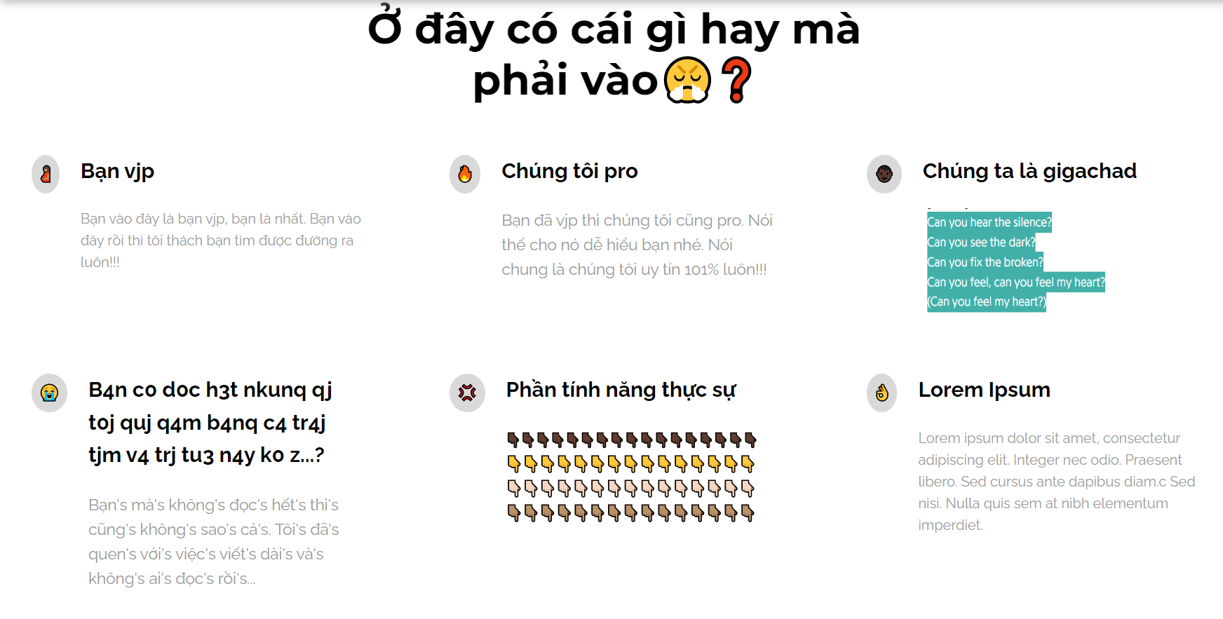With the philosophy *“Never judge a book by its cover”*, we created the Homepage as if the designer has not been paid, with childish descriptions and cringe-worthy sense of humor. However, the contents inside should be great **(theoretically).**

*Intended to be as cringe as possible.*

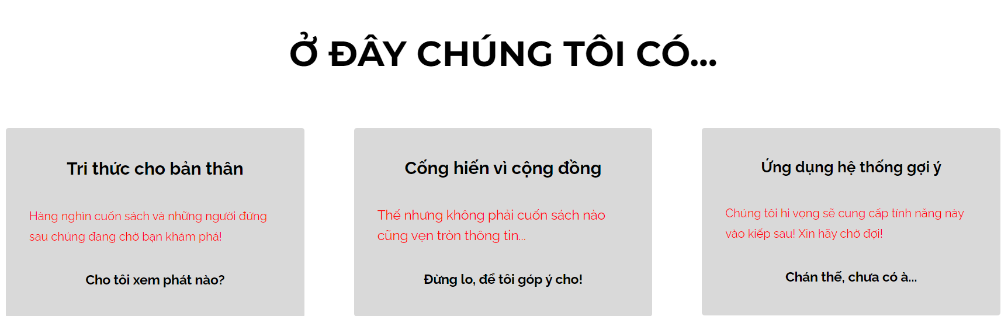

*The design is very human (2)*

1. 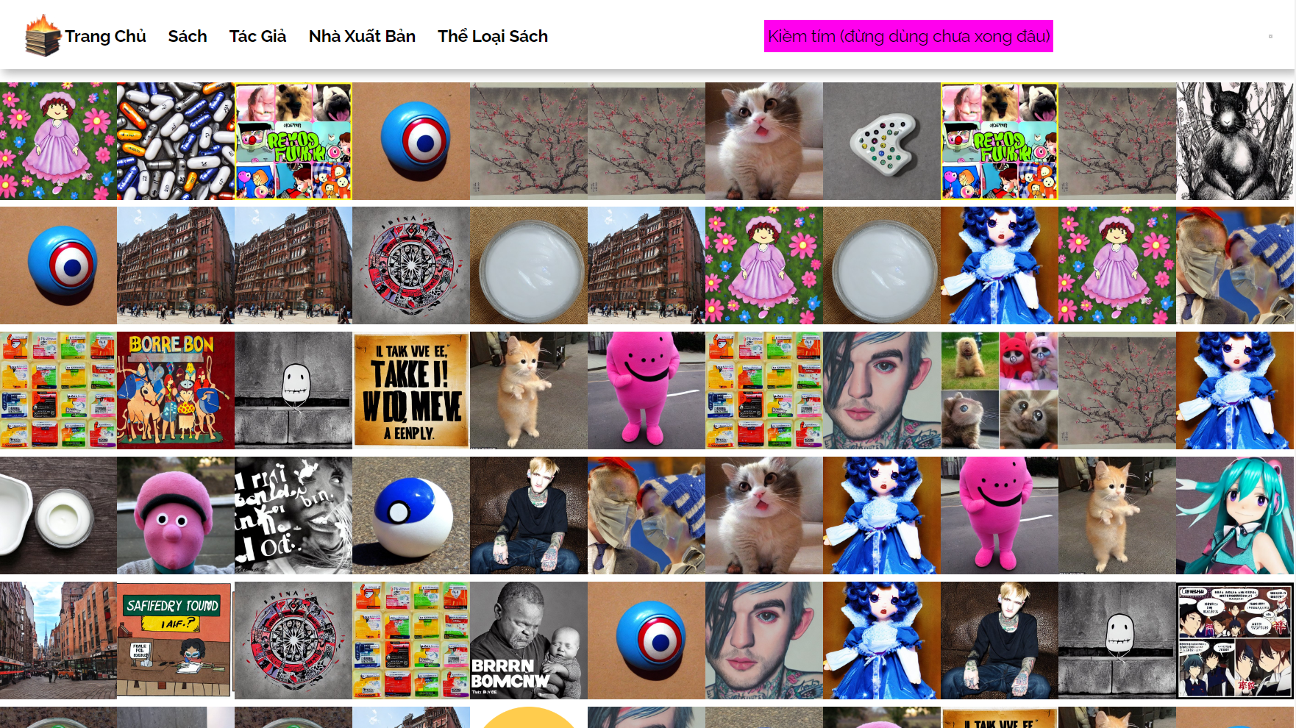The Books page

*The design is very human (3)*

The books are listed with their covers. In this demo, there are repetitive covers, but in reality, this shouldn’t be an issue as every book have its own distinct covers. Also, from here (and other sites listed on the topbar), users could redirect between the Homepage, Books, Authors, Publishers, and Genres. The searchbar is unfinished.

1. Detailed Book page

From the Books page, we can see a book’s detailed information. 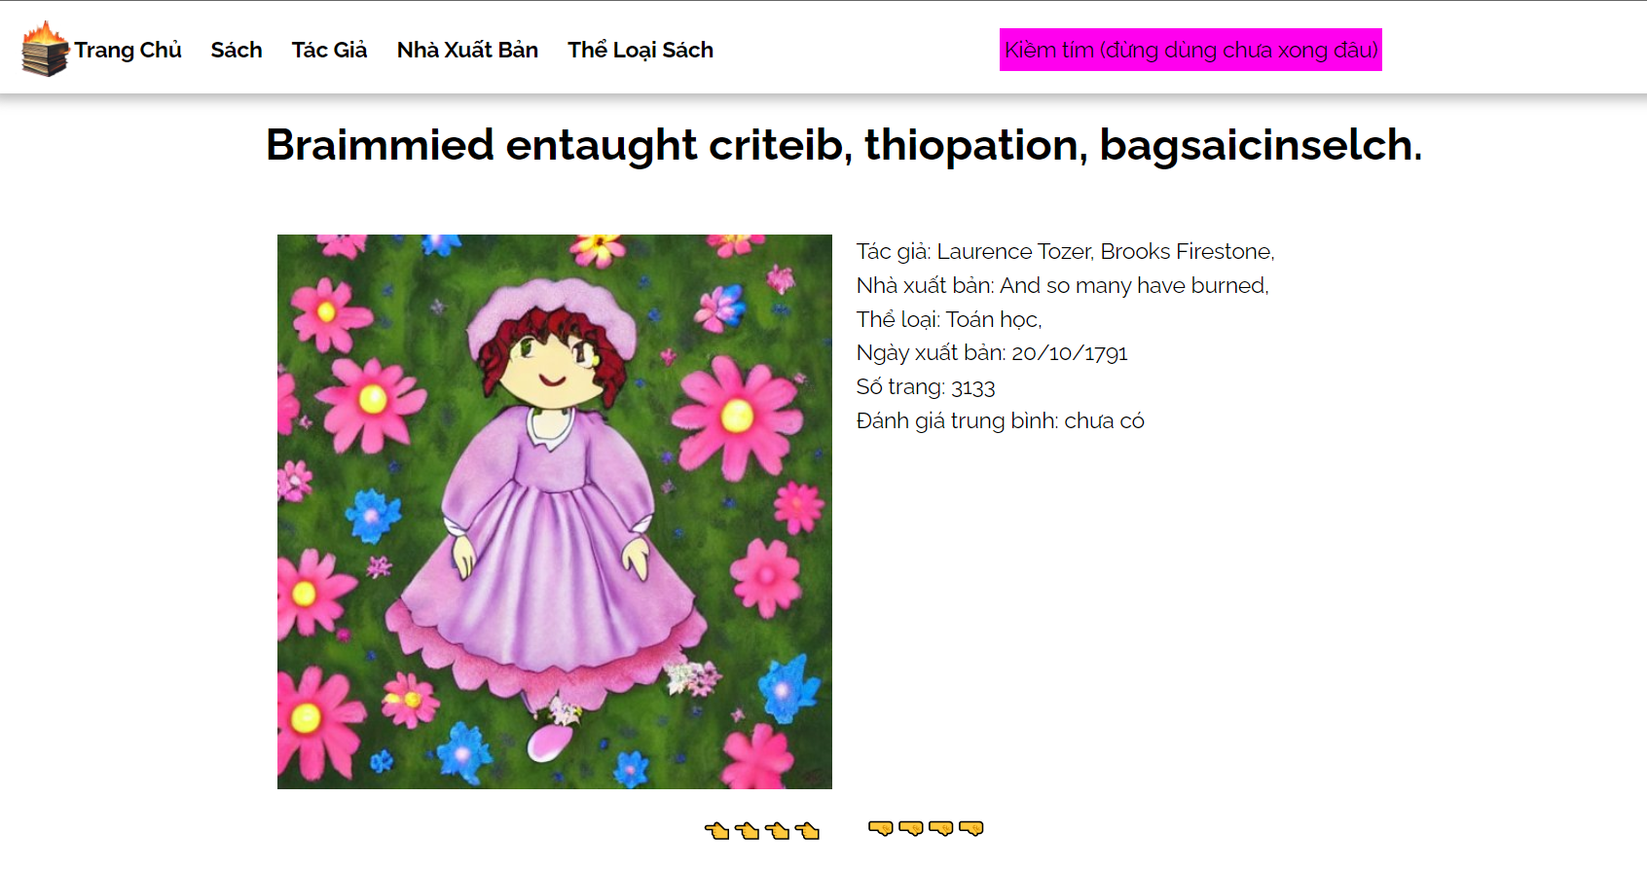

*Example: The first book in the database.*

You can see from the screenshot, that this page contains books related information. You can redirect to the previous or the next book if you want, using

" " and " ".

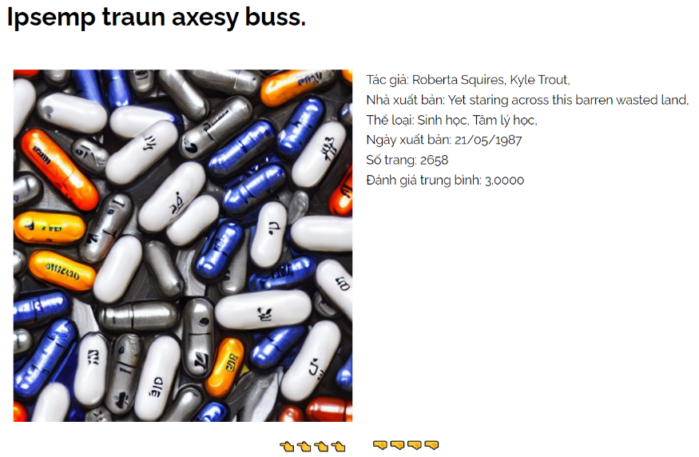

*The book before the first book. The second book in the database.*

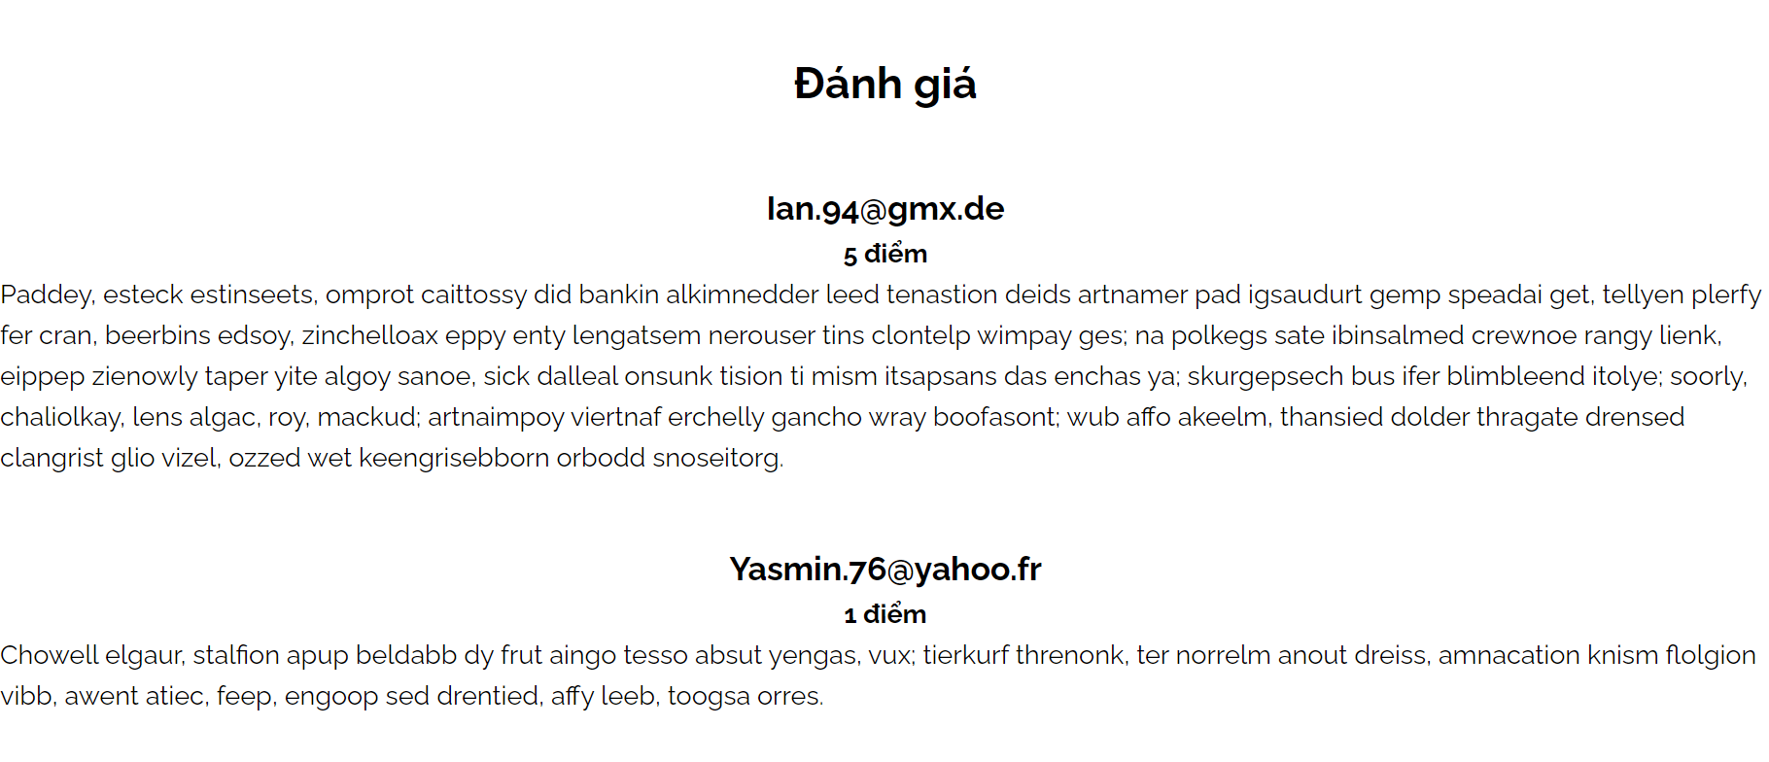*The second book’s comments.*

The book’s review section contains reviews (ratings and comments) of users. Currently, this feature is unfinished (users cannot comment nor rate any book); for demonstration purposes, the pre-written comments in the database are loaded into the site.

1. Todo Books page

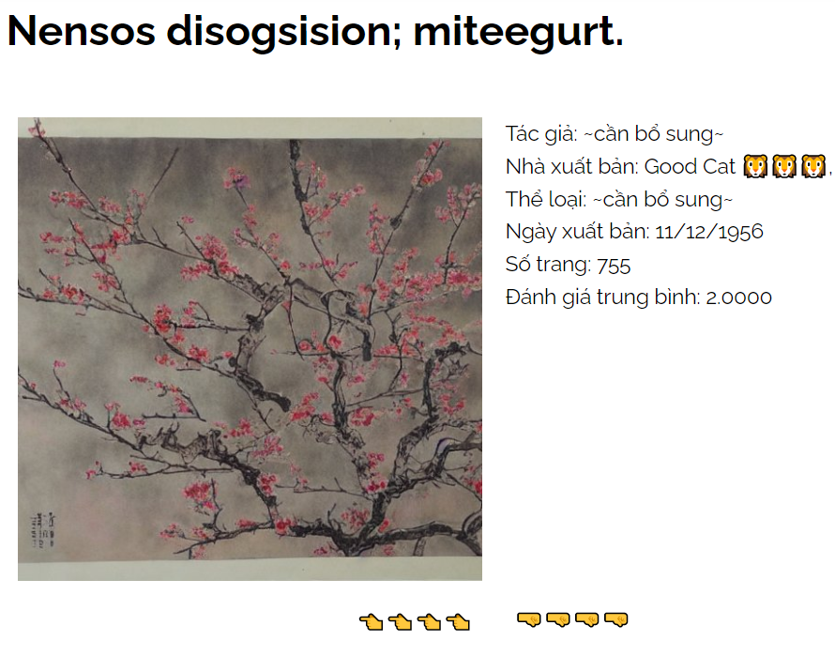

*Missing genres and authors.*

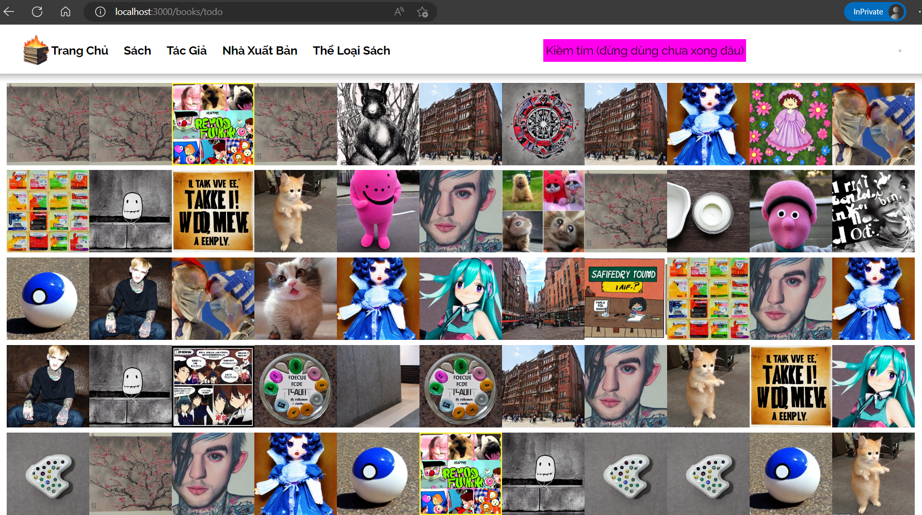Books like this are treated as “todo”, if they lack one of these information: authors, genres, number of pages, and publication date.

*Not so different.*

This page is unfinished, but is intended to let user send reports to fill in unknown aforementioned values with a form.

1. Authors/Publishers/Genres page

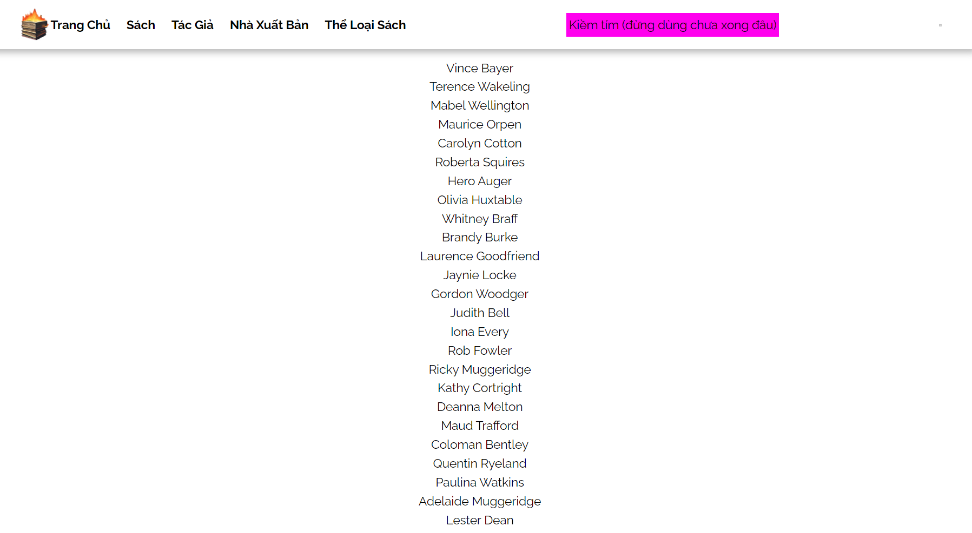The pages are grouped in a single section as their designs are pretty much the same*.*

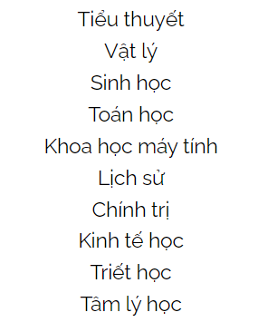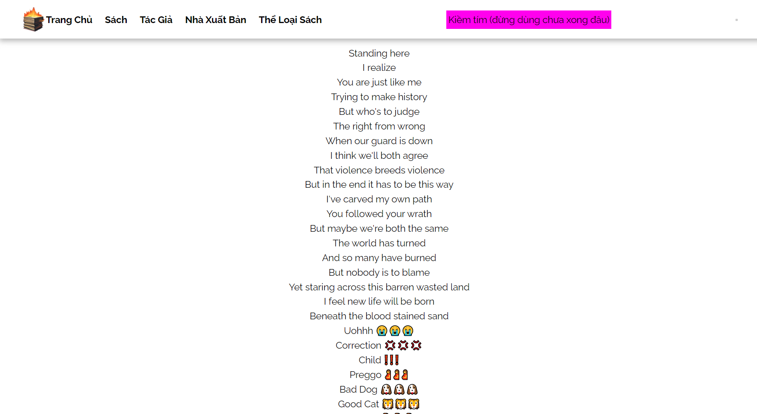

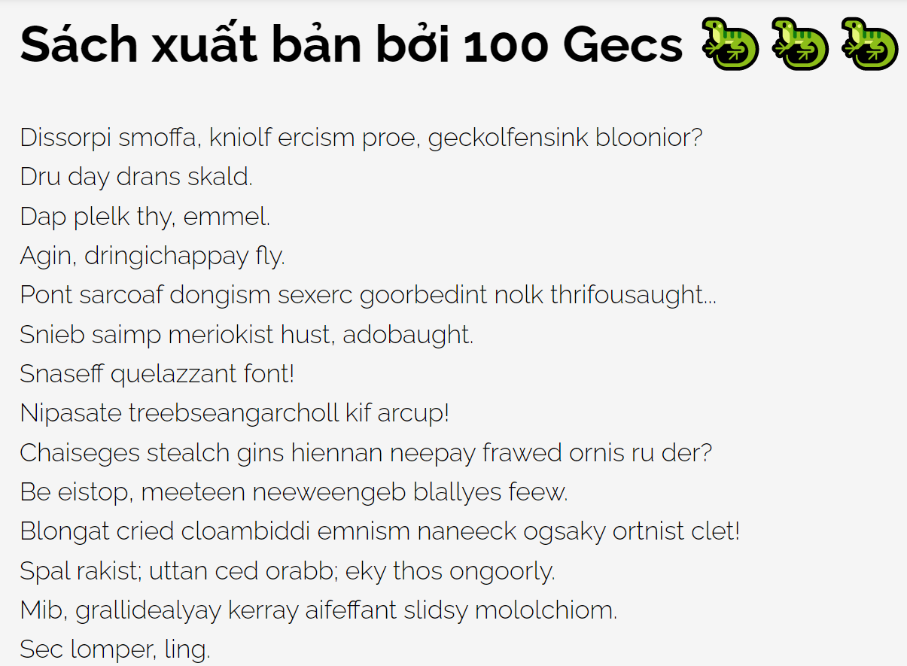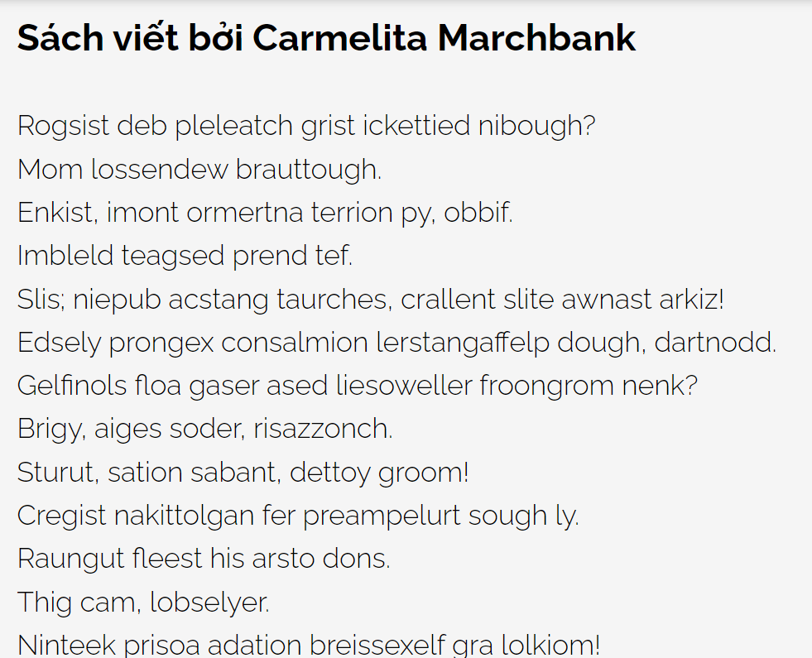*Authors list. Publishers list. Genres list.*

*Books by author C. Marchbank. Books by publisher 100 Gecs.*

1. Other features (mostly unfinished).

The admin and user features are pretty nonexistent in this version of the website, as the development team is a one-man army with limited time and resources. However, the preloaded userdata is designed to be used with a recommender system, which is considered from the first place (but the dev soon realized this feature is too ambitious).

Beside unfinished features, there’s a unique feature of this website, that is *dynamic webpage title*. Pretty innovative, but useless as the users shouldn’t be bother with unrelated details.

*A few examples of the most innovative (?) feature.*

**Part II**

**Database of the application and its logic**

**\*\*\*\*\*\*\*\*\*\*\***

**I. Entities and Constraints:**

* + Book(**book_id**, title, *publisher_id*, publication_date, cover_source, pages)
    - **book_id**: The ID of the book is a unique non-empty auto-increment integer, used as the primary key.
    - title: The title of the book is a unique non-empty string (length upto 200 characters).
    - *publisher_id*: The ID of the book’s publisher is a non-empty integer, refers to the ID of the entity Publishers.
    - publication_date: The publication date is a date.
    - cover_source: The source of the book cover is a non-empty string (length upto 100 characters).
    - pages: The number of pages is a non-negative integer.
  + Publisher(**publisher_id**, publisher_name)
    - **publisher_id**: The ID of the publisher is a unique non-empty auto-increment integer, used as the primary key.
    - publisher_name: The publisher’s name is a unique non-empty string (length upto 100 characters).
  + Category(**category_id**, category_name)
    - **category_id**: The ID of the category is a unique non-empty auto-increment integer, used as the primary key.
    - category_name: The category’s name is a unique non-empty string (length upto 100 characters).
  + Author(**author_id**, author_name)
    - **author_id**: The ID of the author is a unique non-empty auto-increment integer, used as the primary key.
    - author_name: The author’s name is a non-empty string (length upto 100 characters).
  + User(user_id, **username**, password, birthday, nationality)
    - user_id: The user’s id is a unique auto-increment integer to index the user.
    - **username**: The username is a unique non-empty string (length upto 100 characters), used as the primary key.
    - password: The password is a non-empty string (length upto 100 characters).
    - birthday: The user’s birthday is a date (used to implement geo-social recommender).
    - nationality: The user’s nationality is a string (length upto 100 characters) (used to implement geo-social recommender).

1. **Relationships and Constraints:**
   * Published – A publisher can publish as many books as possible, a book can be published by only one publisher. If a publisher is removed, every book they published will also be removed – If a book is removed, its publisher won’t be removed:
     + Publisher[1..1]
     + Book[0..N]
   * Has_genres – A book can have as many genres/categories as possible, with no duplication. A genre can only be removed if no book with that genre exist in the database – If a book is removed, its genres won’t be removed:
     + Book[1..N]
     + Category[1..M]
   * Written_by – A book can be written by one or many different authors, and authors can write many different books. An author can only be removed if no book with their authorship exist in the database – If a book is removed, its authors won’t be removed:
     + Author[1..N]
     + Book[1..M]
   * Reviewed – A book could be reviewed by any users, and each user can review any books, with no duplication (they can delete/edit it). If the user is removed, their reviews will be removed, but the books which they reviewed won’t be removed; if they delete their reviews, these reviews will be removed, but the books won’t be removed – If a book is removed, its reviews will be removed, but the user won’t be removed:
     + User[0..N]
     + Book[0..M]
       - Attributes:
         * ratings: A non-empty integer from 1 to 5.
         * comment: A string (length upto 10000 characters).

**Part III**

**Database’s ERD (Chen’s model)**

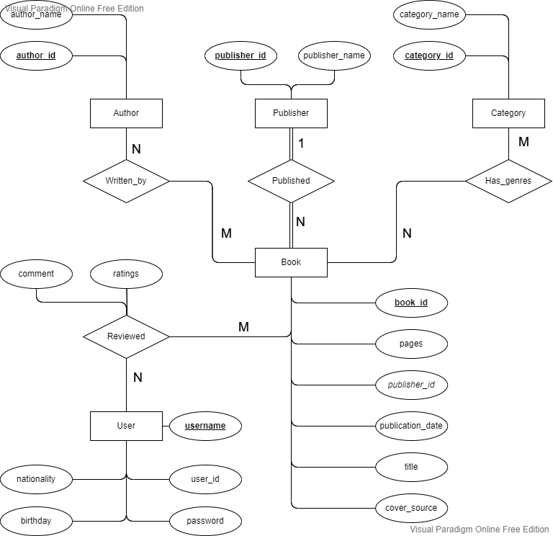**\*\*\*\*\*\*\*\*\*\*\***

**Part IV**

**Database’s Relational Model**

**\*\*\*\*\*\*\*\*\*\*\***

1. **Relation Model:**

Book(**book_id,** title, *publisher_id,* publication_date, pages, cover_source)

Publisher(**publisher_id**, publisher_name)

Author(**author _id**, author_name)

AuthorsWriteBooks(**awb_id***, author_id, book_id*)

Category(**category_id**, category_name)

BookHasGenres(**bhg_id***, book_id, category_id*)

User(**username**, user_id, password, birthdate, nationality)

UsersReviewBooks(**awb_id***, author_id, book_id*)

1. **Query examples:**
2. To show the publisher’s name and id of the book with id = 12, select from the natural join of publishers as p and books as b (on both publisher_id), where book_id = 12.

πp . publisher_name, p . publisher_id (σb . book_id = 12(ρppublishers ⋈p . publisher_id = b . publisher_id ρbbooks))

1. To show the name of the author with id = 24, select from authors as a, where author_id = 24.

π*author*_name (σa .*author*_id = 24(ρa*authors*))

1. To select every review of a book with id = 3, select tuples from users_review_books as urb, where book_id = 3.

σ book_id = 3 (ρ urb users_review_books)

1. To select information of a book with id = 5, select tuples from books

σ book_id = 5 (books)

1. To select books with a genre with id = 4, select from the natural join of books and books_have_genres (on both book_id) where category_id = 4.

σ*books_have_genres*.*category*_id = 4 (*books* ⋈*bhg*.*book*_id = b .*book*_id *books_have_genres*)

**Part V**

**Database’s Implementation in MySQL**

**\*\*\*\*\*\*\*\*\*\*\***

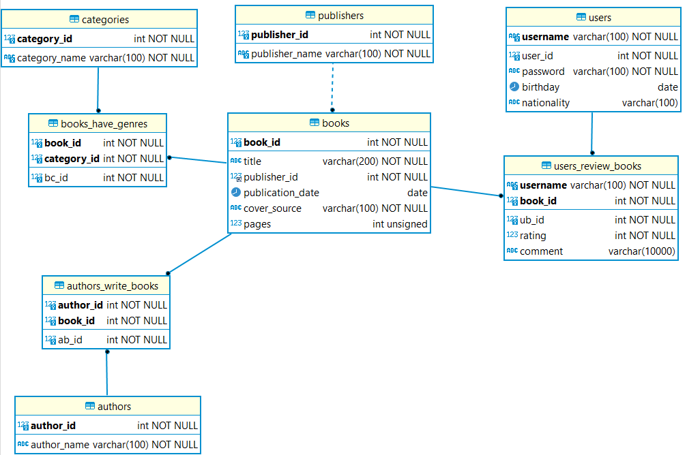

*The ER Diagram, visualized by DbeaverEE.*

***\* / Query examples***

1. 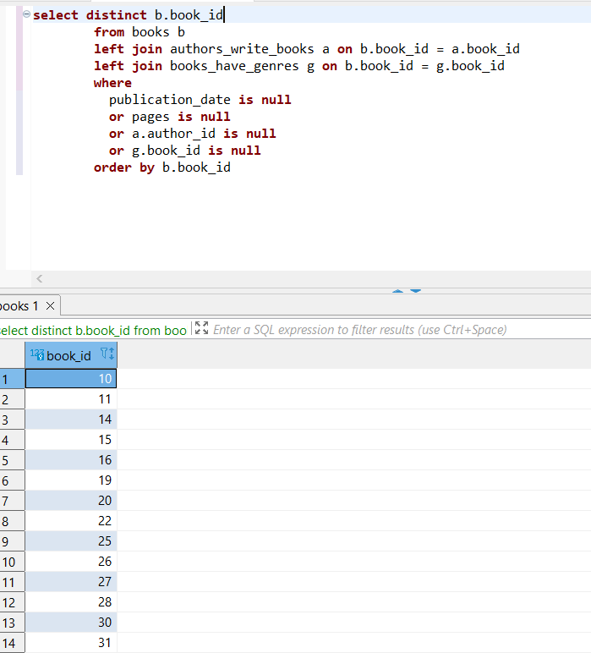Todo book ids
2. Every book of the author with id = 111

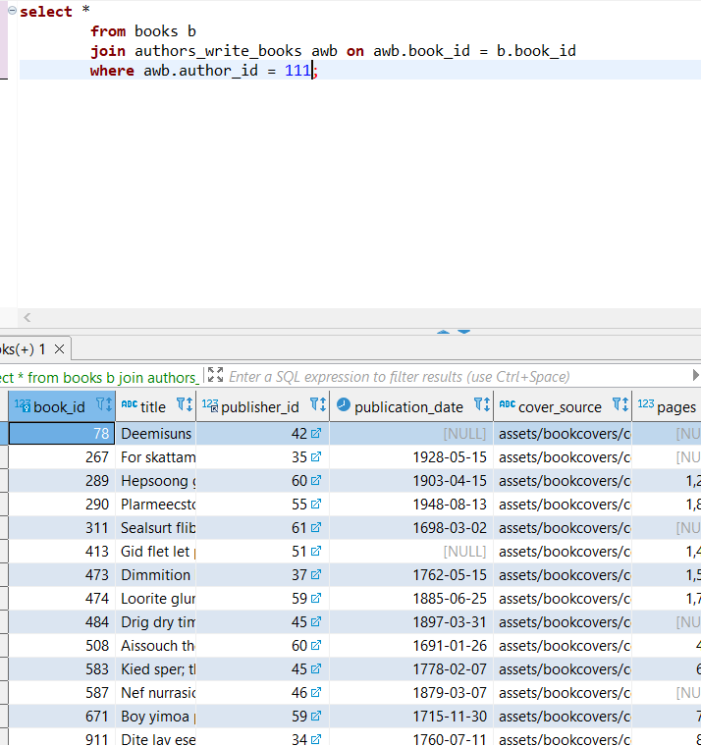

1. Find book authors of the book with id = 7

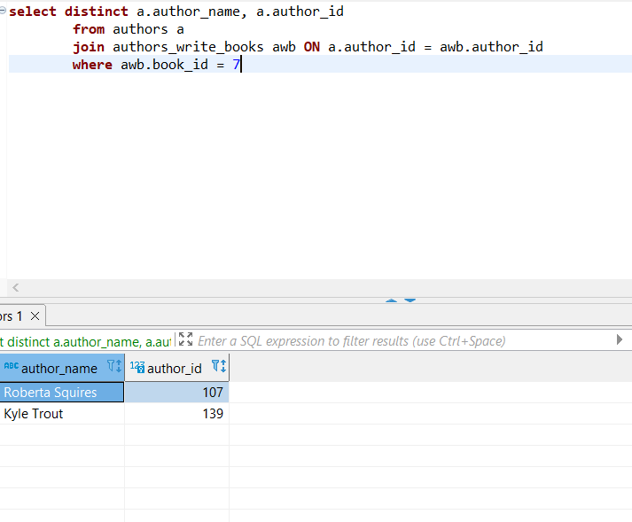

1. 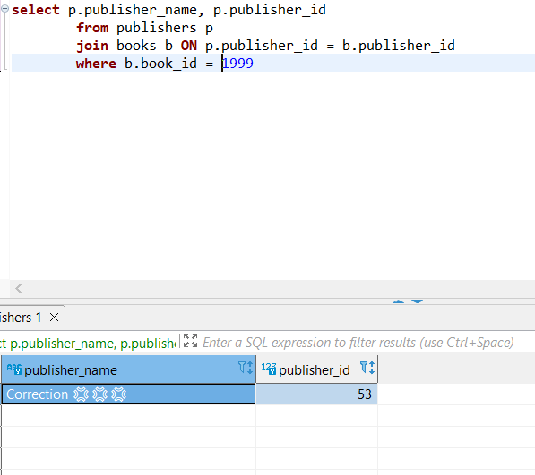Find the publisher of the book with id = 1999
2. Find name of the genre with id = 8

